# **NEESAE: Neighboring** **Envelope Embedded Stacked Autoencoder**

**Table 1** Comparison of original sample and sample-pair

|  |  |  |  |  |
| --- | --- | --- | --- | --- |
| Dataset |  | OF (%) | OF&PCA (%) | OF&LDA (%) |
| AD | Original sample | 54.00±9.55 | 60.00±8.50 | 62.67±4.94 |
| Sample-pair | **64.67±4.47** | **70.67±4.35** | **72.00±6.91** |
| LSVT | Original sample | 80.48±6.39 | 90.48±3.37 | 87.14±3.61 |
| Sample-pair | **94.29±3.98** | **96.67±1.30** | **95.71±3.91** |
| PD | Original sample | 62.70±1.86 | 64.94±1.95 | 64.20±1.74 |
| Sample-pair | **70.75±1.74** | **71.90±1.06** | **73.22±1.67** |
| Pendigits | Original sample | **98.13±0.05** | **98.07±0.13** | **97.87±0.23** |
| Sample-pair | 66.36±0.98 | 68.56±2.40 | 64.63±1.84 |
| Statlog | Original sample | **86.13±0.53** | **87.23±0.54** | **87.09±0.63** |
| Sample-pair | 82.07±1.10 | 85.85±0.36 | 82.89±1.07 |
| Vehicle | Original sample | 80.35±1.31 | 82.34±1.05 | 82.55±0.92 |
| Sample-pair | **83.90±0.19** | **85.32±0.78** | **85.53±1.05** |
| heart | Original sample | 80.89±4.26 | 85.11±3.30 | 83.33±3.60 |
| Sample-pair | **85.56±2.83** | **90.67±2.02** | **90.67±2.30** |
| Maxlettle | Original sample | 85.54±4.01 | 88.00±2.28 | 88.62±4.16 |
| Sample-pair | **86.77±2.57** | **91.08±3.15** | **90.78±1.09** |
| Urban | Original sample | **79.91±3.87** | **82.40±2.80** | **83.38±2.10** |
| Sample-pair | 73.42±2.48 | 75.73±2.87 | 75.02±2.02 |
| WDBC | Original sample | 95.66±1.52 | 97.88±0.84 | 97.46±0.69 |
| Sample-pair | **97.57±1.38** | **98.73±1.16** | **99.58±0.44** |
| Wisconsin | Original sample | 96.30±1.72 | 97.18±1.19 | 96.83±1.26 |
| Sample-pair | **97.18±1.48** | **98.06±0.74** | **97.89±1.26** |
| PID | Original sample | 70.39±2.74 | 72.34±1.98 | 75.78±3.49 |
| Sample-pair | **74.14±4.27** | **80.16±1.78** | **82.34±1.88** |

**Table 2** Comparison of sample-pair and sample-pair &ICMC

|  |  |  |
| --- | --- | --- |
| Dataset | Sample-pair (%) | Sample-pair &ICMC (%) |
| AD | 64.67±4.47 | **66.00±5.96** |
| LSVT | 94.29±3.98 | **95.71±3.91** |
| PD | 70.75±1.74 | **70.86±1.63** |
| Pendigits | 66.36±0.98 | **69.61±1.62** |
| Statlog | 82.07±1.10 | **85.13±0.30** |
| Vehicle | **83.90±0.19** | 77.66±0.43 |
| heart | 85.56±2.83 | **92.00±3.08** |
| Maxlettle | 86.77±2.57 | **87.69±3.61** |
| Urban | 73.42±2.48 | **76.49±1.90** |
| WDBC | 97.57±1.38 | **99.58±0.24** |
| Wisconsin | 97.18±1.48 | **98.24±0.82** |
| PID | 74.14±4.27 | **79.14±1.42** |

**Table 3** MSEM effectiveness analysis experimental comparison

|  |  |  |  |  |  |
| --- | --- | --- | --- | --- | --- |
| Dataset | OS (%) | PS (%) | SS (%) | MSEM (%) | |
| MV | WF |
| AD | 73.33±6.24 | 84.67±10.70 | 83.33±8.50 | **90.67±6.41** | 88.00±7.30 |
| LSVT | 96.19±3.61 | 90.00±13.08 | 87.62±12.19 | **96.67±3.61** | 93.33±4.26 |
| PD | 74.43±1.61 | 72.36±1.68 | 73.76±6.64 | 77.76±3.79 | **78.74±4.22** |
| Vehicle | 80.08±2.49 | 83.59±4.96 | 86.02±3.79 | 87.66±2.97 | **89.53±1.96** |
| Pendigits | 83.74±0.62 | 67.47±5.11 | 70.93±6.92 | 79.61±7.99 | **84.21±0.83** |
| Statlog | 88.33±0.18 | 78.29±4.52 | 80.73±4.41 | 86.03±1.05 | **87.93±0.93** |
| Urban | 82.02±2.50 | 54.84±6.66 | 51.11±5.63 | 65.69±6.06 | **84.29±3.38** |
| heart | 92.52±3.19 | 94.72±2.46 | 99.17±1.06 | 97.78±2.57 | **99.44±1.11** |
| WDBC | 97.62±2.68 | 99.74±0.31 | 100.00±0.00 | 99.87±0.26 | **100.00±0.00** |
| Maxlettle | 95.08±2.28 | 91.38±6.21 | 94.78±4.56 | **96.92±1.09** | 96.25±5.07 |
| Wisconsin | 99.19±1.28 | 98.68±0.88 | 99.11±0.87 | **99.89±0.21** | 98.88±3.07 |
| PID | 80.08±2.49 | 85.31±1.58 | 86.41±3.80 | 88.20±2.63 | **89.38±1.88** |

**Table 4** NSELM and ESAE effectiveness analysis experimental comparison

|  |  |  |  |
| --- | --- | --- | --- |
| Dataset | NE_ESAE without NSELM (%) | NE_ESAE without ESAE (%) | NE_ESAE (%) |
| AD | 60.00±3.33 | 79.33±14.41 | **90.67±6.41** |
| LSVT | 80.48±8.81 | 96.19±5.98 | **96.67±3.61** |
| PD | 63.33±4.80 | 72.82±3.18 | **78.74±4.22** |
| Vehicle | 78.58±6.70 | 80.99±2.85 | **89.53±1.96** |
| Pendigits | **98.51±0.27** | 67.40±1.49 | 84.21±0.83 |
| Statlog | 85.32±2.83 | 83.53±0.63 | **87.93±0.93** |
| Urban | 74.29±1.32 | 74.82±5.66 | **84.29±3.38** |
| heart | 84.44±5.88 | 96.89±2.53 | **99.44±1.11** |
| WDBC | 96.17±1.43 | 99.79±0.29 | **100.00±0.00** |
| Maxlettle | 86.15±3.08 | 89.23±5.76 | **96.92±1.09** |
| Wisconsin | 97.35±0.88 | 99.50±0.48 | **99.89±0.21** |
| PID | 73.44±7.14 | 82.50±2.28 | **89.38±1.88** |

**Table 5** Comparison of different feature-learning algorithms

|  |  |  |  |  |  |  |  |  |
| --- | --- | --- | --- | --- | --- | --- | --- | --- |
| Dataset | OF (%) | PCA (%) | LDA (%) | LPP (%) | Relief (%) | Lasso (%) | P_value (%) | **NE_ESAE** (%) |
| AD | 54.00 | 60.00 | 62.67 | 60.67 | 54.00 | 54.00 | 48.67 | **90.67** |
| ±9.55 | ±8.50 | ±4.94 | ±7.60 | ±10.90 | ±9.55 | ±7.67 | **±6.41** |
| LSVT | 80.48 | 90.48 | 87.14 | 90.48 | 88.57 | 76.67 | 75.71 | **96.67** |
| ±6.39 | ±3.37 | ±3.61 | ±3.76 | ±3.10 | ±5.16 | ±5.93 | **±3.61** |
| PD | 62.70 | 64.94 | 64.20 | 65.29 | 64.08 | 62.70 | 56.61 | **78.74** |
| ±1.86 | ±1.95 | ±1.74 | ±1.47 | ±1.13 | ±1.86 | ±3.92 | **±4.22** |
| Vehicle | 80.35 | 82.34 | 82.55 | 81.77 | 78.16 | 80.78 | 75.39 | **89.53** |
| ±1.31 | ±1.05 | ±0.92 | ±0.89 | ±0.19 | 1.05 | ±0.89 | **±1.96** |
| Pendigits | **98.13** | 98.07 | 97.87 | 97.97 | 97.82 | 98.13 | 92.87 | 84.21 |
| **±0.05** | ±0.13 | ±0.23 | ±0.11 | ±0.23 | ±0.05 | ±1.46 | ±0.83 |
| Statlog | 86.13 | 87.23 | 87.09 | 87.27 | 86.10 | 86.15 | 86.13 | **87.93** |
| ±0.53 | ±0.54 | ±0.63 | ±0.48 | ±0.40 | ±0.51 | ±0.68 | **±0.93** |
| Urban | 79.91 | 82.40 | 83.38 | 82.93 | 80.18 | 79.91 | 80.44 | **84.29** |
| ±3.87 | ±2.80 | ±2.10 | ±2.53 | ±2.53 | ±3.84 | ±2.67 | **±3.38** |
| heart | 78.89 | 85.33 | 84.67 | 84.22 | 81.78 | 78.29 | 62.00 | **99.44** |
| ±3.42 | ±2.53 | ±2.14 | ±3.37 | ±3.00 | ±3.42 | ±4.67 | **±1.11** |
| WDBC | 95.66 | 97.88 | 97.46 | 97.35 | 97.04 | 95.78 | 88.78 | **100.00** |
| ±1.52 | ±0.84 | ±0.69 | ±0.53 | ±1.43 | ±1.54 | ±2.19 | **±0.00** |
| Maxlettle | 84.62 | 88.62 | 88.62 | 86.77 | 85.85 | 85.23 | 76.62 | **96.92** |
| ±3.92 | ±2.79 | ±4.16 | ±4.43 | ±5.03 | ±4.16 | ±2.75 | **±1.09** |
| Wisconsin | 96.30 | 97.18 | 96.83 | 97.00 | 96.74 | 96.30 | 93.66 | **99.89** |
| ±1.72 | ±1.19 | ±1.26 | ±1.18 | ±1.83 | ±1.72 | ±1.67 | **±0.21** |
| PID | 70.40 | 72.34 | 75.78 | 69.67 | 73.29 | 70.39 | 73.91 | **89.38** |
| ±2.74 | ±1.98 | ±3.49 | ±5.54 | ±4.51 | ±2.74 | ±3.55 | **±1.88** |

**Table 6** Classification accuracy (mean ±variance) of proposed algorithm with different classifiers

|  |  |  |  |
| --- | --- | --- | --- |
| Dataset | SVM (%) | RF (%) | ELM (%) |
| AD | **90.67±6.41** | 88.00±8.69 | 82.6714.61 |
| LSVT | 96.67±3.61 | **97.62±2.38** | 97.14±3.91 |
| PD | **78.74±4.22** | 77.67±5.25 | 76.67±6.30 |
| Vehicle | **89.53±1.96** | 80.00±8.11 | 80.99±7.34 |
| Pendigits | 84.21±0.83 | 82.78±1.79 | **85.17±1.35** |
| Statlog | **87.93±0.93** | 81.61±2.49 | 82.99±1.93 |
| Urban | **84.29±3.38** | 75.18±5.45 | 82.14±4.60 |
| heart | **99.44±1.11** | 98.89±1.28 | 98.33±2.13 |
| WDBC | **100.00±0.00** | **100.00±0.00** | 99.87±0.26 |
| Maxlettle | 96.92±1.09 | **98.75±1.71** | **98.75±1.71** |
| Wisconsin | **99.89±0.21** | 99.41±0.51 | 99.71±0.51 |
| PID | 89.38±1.88 | **89.84±2.47** | 89.38±2.25 |

**Table 7.** Classification accuracy (mean ±variance) of different deep autoencoder classifiers

|  |  |  |  |  |  |  |  |
| --- | --- | --- | --- | --- | --- | --- | --- |
| Dataset | SAE (%) | SSAE (%) | SDSAE (%) | SPSAE (%) | ESGSAE_FF (%) | GSTAE (%) | **NE_ESAE** (%) |
| AD | 50.67±7.95 | 56.67±5.27 | 55.58±4.36 | 57.78±4.27 | 67.33±2.49 | 71.11±8.16 | **90.67±6.41** |
| LSVT | 83.80±5.16 | 83.33±5.83 | 76.62±5.29 | 84.33±5.36 | 92.76±0.62 | 84.66±4.32 | **96.67±3.61** |
| PD | 61.15±2.91 | 64.48±2.05 | 64.88±1.84 | 64.22±2.34 | 66.72±0.87 | 73.89±4.27 | **78.74±4.22** |
| Urban | 74.48±3.33 | 79.73±0.67 | 75.17±1.88 | 77.81±1.17 | 83.20±1.01 | 76.98±0.73 | **84.29±3.38** |
| Vehicle | 67.30±3.33 | 70.00±2.99 | 72.00±2.25 | 74.76±2.93 | 81.91±0.42 | 79.71±2.93 | **89.53±1.96** |
| Pendigits | 89.64± 1.44 | 93.80± 0.51 | 94.58 ± 0.53 | 91.60 ± 0.57 | **98.00 ±0.12** | 93.53±0.77 | 84.21±0.83 |
| Statlog | 83.67± 0.36 | 84.85± 0.84 | 83.65± 0.71 | 85.87± 0.86 | 87.28±0.12 | 85.42±0.38 | **87.93±0.93** |

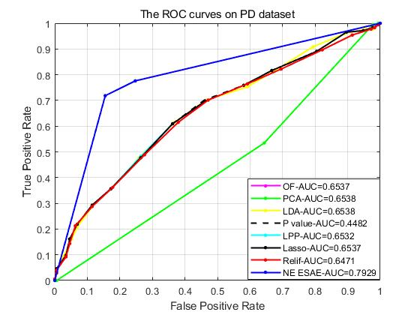

(a) The description of the ROC curves on PD

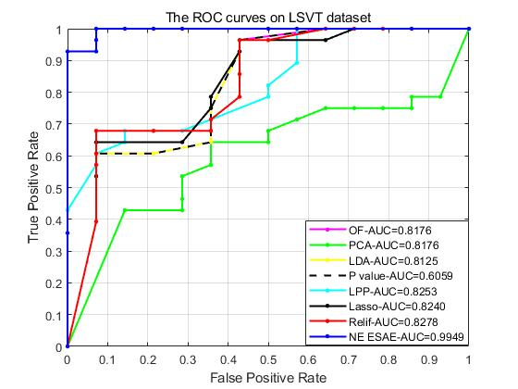

(b) The description of the ROC curves on LSVT

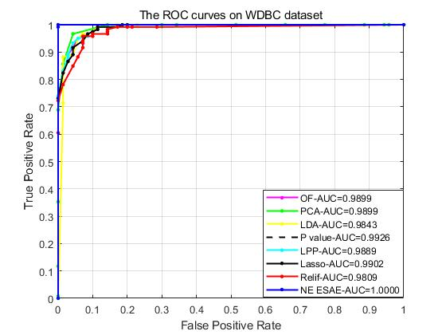

Figure 1. (c) The description of the ROC curves on WDBC

|  |  |
| --- | --- |
| (a)AD | (b)PD |

Figure.2 The effect of cluster ratio on the performance of the proposed algorithm

|  |  |
| --- | --- |
| 1. Maxlettle | 1. PID |
| 1. LSVT | 1. Wisconsin |
| (e) Statlog | (f) Urban |

Figure.3 The confusion matrix under different datasets